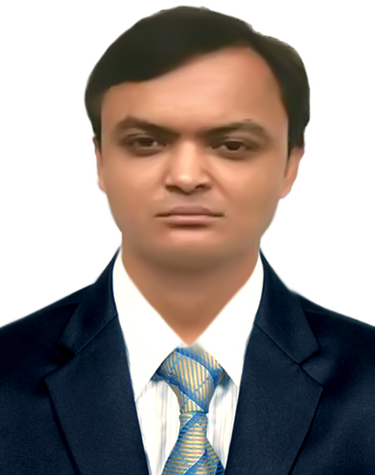

RESUME Of Hasanul Islam Contact Details
QUDRAT-E-KHUDA HALL
DUET, Gazipur-1707
+8801744780744
sumonmeduet@gmail.com

CAREER OBJECTIVES | : | To pursue a highly rewarding career, seeking for a job in challenging and healthy work environment where I can utilize my skills and knowledge efficiently for organizational growth. To succeed in an environment of growth and excellence and earn a job satisfaction and Self-development and help me achieve personal as well as organizational goals.

PROFESSION : MECHANICAL ENGINEER

SCHOLASTIC RECORDS | : | Certificate  Department  University  Duration  Year of Passing  CGPA | Bachelor of Science in Engineering  Mechanical Engineering  Dhaka University of Engineering & Technology (DUET), Gazipur-1707  Four years  2018  2.77 (out of 4.00)
 | : | Certificate  Department  Institute  Duration  Board  Year of Passing  CGPA | Diploma in Engineering  Power Technology  Bogura Polytechnic Institute, Bogura.  Four years  Bangladesh Technical Education Board (BTEB), Dhaka.  2014  3.43 (out of 4.00)
 | : | Certificate  School  Board  Group  Duration  Year of passing  CGPA | Secondary School Certificate  Bhaduria High School & College  Dinajpur  Science  2 Years.  2010  5.00( out of 5.00 )

FOUNDER  PARTICIPATION  PROGRAM  COMPUTER SKILLS |  | : Certificate  Certificate  Institute  Duration Workshop time  Operating System  MS Office  Photo Editing Software  Video Editing Software  CAD Software | An Online Educational Channel for Engineers.  August 6, 2017  GREEN BUILDING & LEED  Triangle Engineers Ltd, Uttara, Dhaka  Two Months (8 Classes)  March-April 2019  Windows XP,7,8, 8.1,10  Microsoft Word, Excel, Power Point.  Adobe Photoshop, Adobe Illustrator  Adobe Primer Pro, HitFlim Express, Camtasia, Flimmora.  AutoCAD (2D & 3D), Solid work.
INDUSTRIAL  TRAINING  PROJECT & THESIS  INDUSTRIAL  VISITS | : | I have been completed 3 Month Industrial attachment training program from “Bangladesh Machine Tools Industry, Gazipur.  (24.09.2014 to 25.11.2014).  "Design of a Epicycle Gear  Supervised by: Professor Mr. Md. Kamruzzaman  Department of Mechanical Engineering  Dhaka University of Engineering & Technology  1. Seven Rings Cement, Kaligong, Gazipur  2. Ashuganj power station company Ltd, Ashuganj  3. PRAN-RFL Industrial Park, Hobiganj, Sylhet.  4. Bengal poly & paper sack ltd. Domna, Kashimpur, Gazipur  5. North West Power Generation Company Ltd, Khulna

SPECIALITY | : | Hardworking, Strong analytical skill  Managerial capability, Sincerity & punctuality.

LANGUAGE SKILLS | : Speaking and writing proficiency in Bengali and English.  : Able to learn anything very quickly.
PERSONAL INFORMATION
Place & Date of Birth  Sex  Religion  Nationality  Interest  National ID No  Permanent Address | :  :  :  :  :  :  : | Bazitpur, 6th October 1994.  Male.  Islam.  Bangladeshi (By Birth).  Traveling, Sports, Drawing  7779047864  Vill: Bazitpur, P.O: Borobaria  P.S: Nawabgonj Dist: Dinajpur | Marital Status  Height  Blood Group | : Unmarried  : 5ft 8 inch  : B+ve

 | Reference  1.Professor Dr. Mohammad Asaduzzaman  Chowdhury  Department of Mechanical Engineering &  Head, Industrial & Production Engineering  Dhaka University of Engineering & Technology, Gazipur-1707, Bangladesh.  Cell: 01766589508  Email: asad@duet.ac.bd. |  | 2. Professor Dr. Md. Arefin Kowser  Department of Mechanical Engineering &  Head  Department of Materials Science & Engineering,  Dhaka University of Engineering & Technology,  Gazipur-1707, Bangladesh.  Cell: 01754-262832  Email: nadimduet@yahoo.com

If you are interested about me, please contact: +8801744780744, sumonmeduet@gmail.com
I am undersigned, hereby declare that I will be responsible for any wrong information provided here.

Date:……05/03/2020………. |   -----------------------------------  Hasanul Islam

